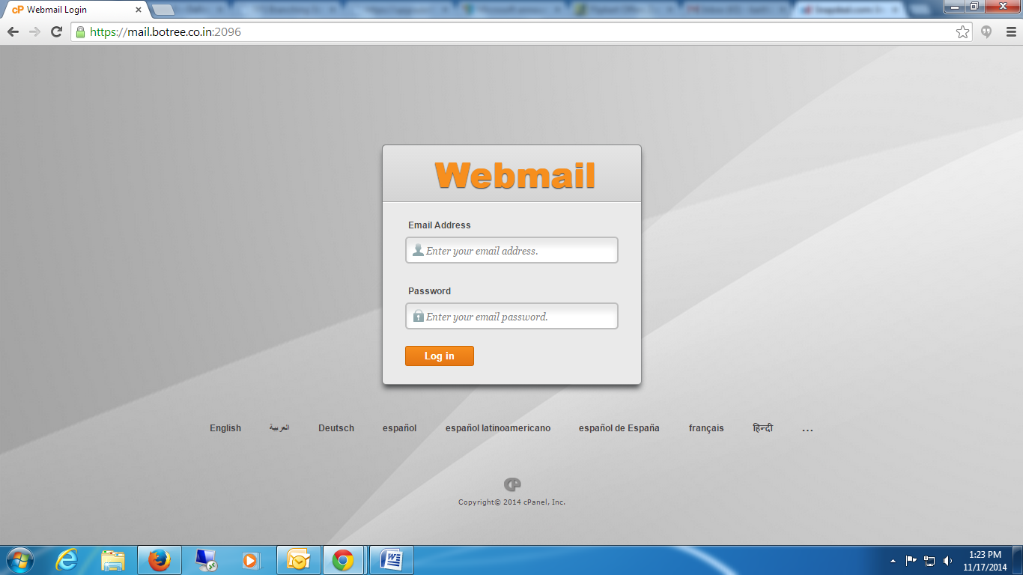

1 🡪 Login to Webmail for using “**https://mail.botree.co.in:2096**”

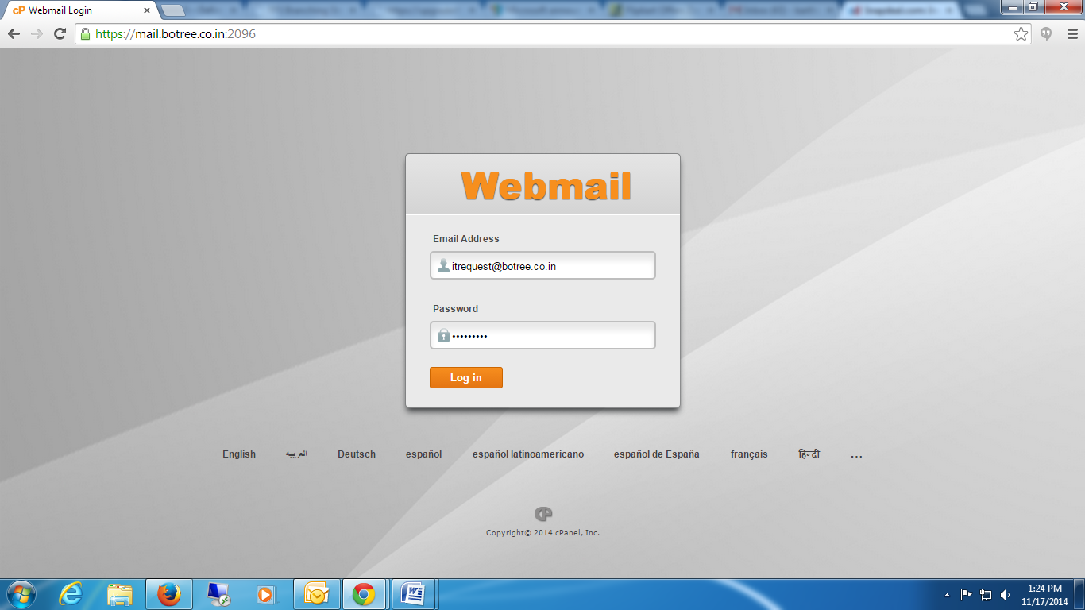

2 🡪 Enter the “mail ID and Password”

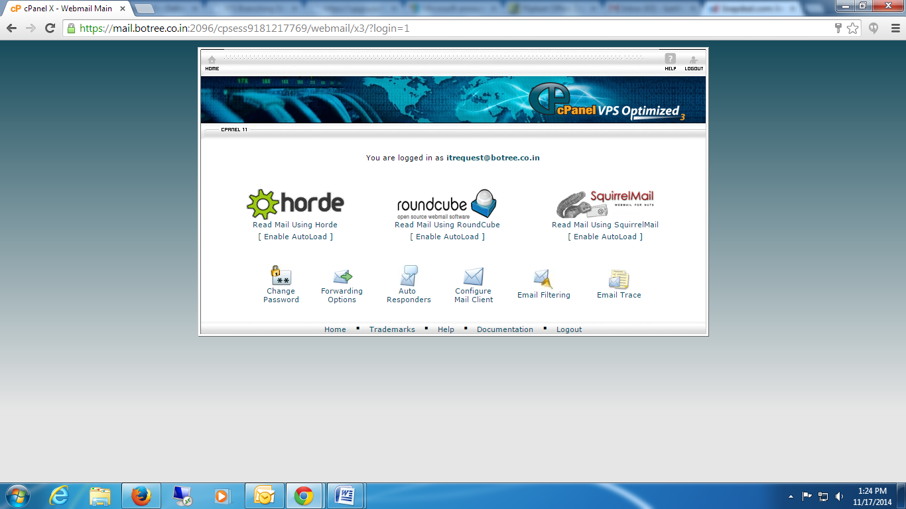

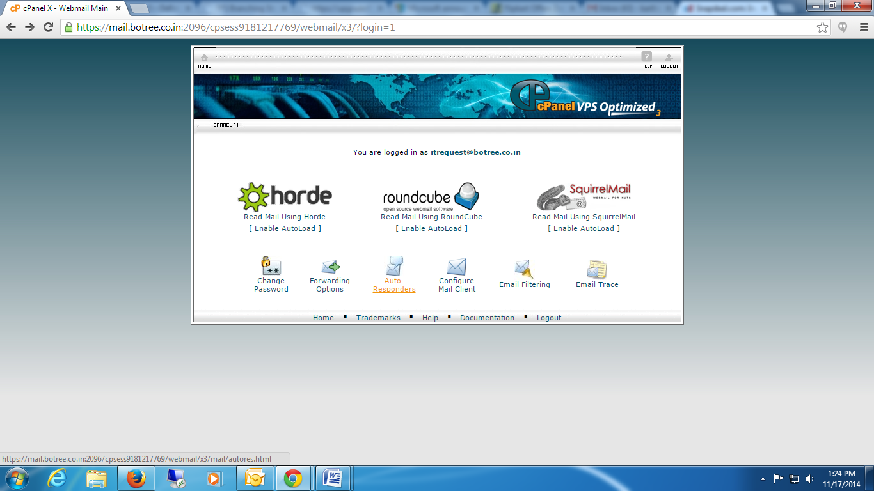

3 🡪 Click on “Auto Responders”

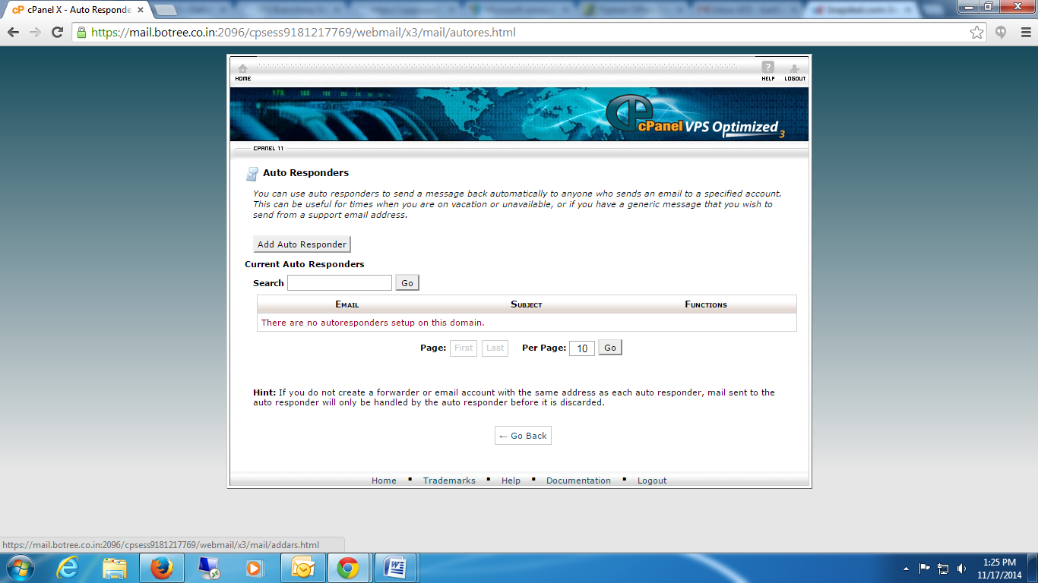

4 🡪 Click “Add Auto Responders”

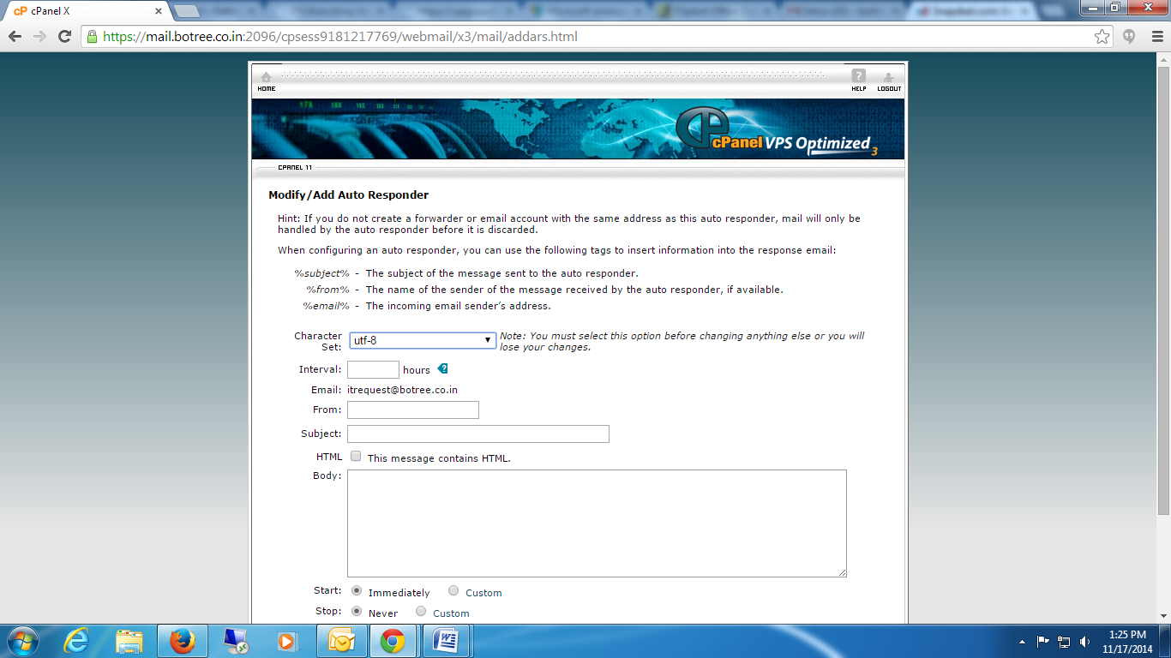

5 🡪 Enter the Details

Intervals: “0”

From: “Enter your Mail ID”

Subject: “Type the subject “

Body: “Enter the Message “

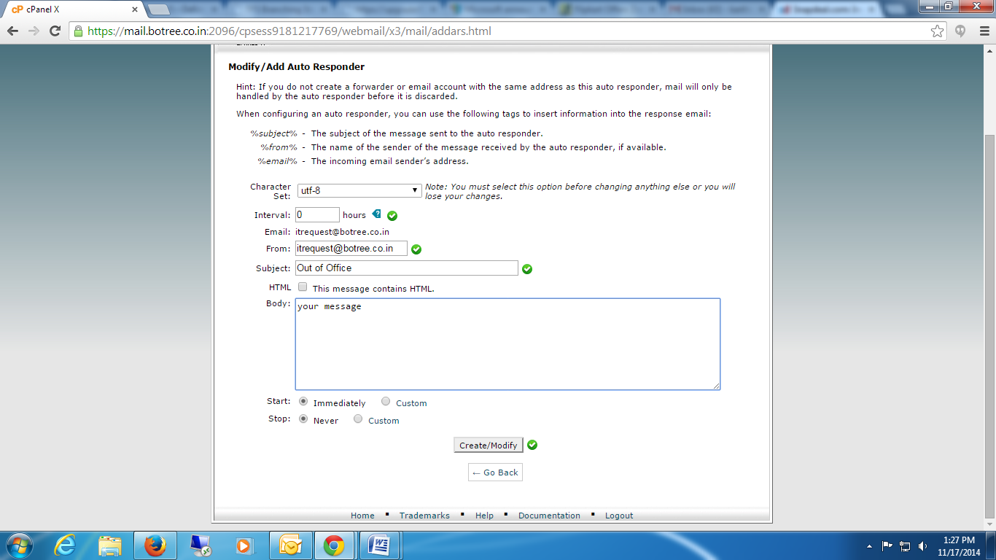

6 🡪 Click “Create/Modify” button